**WB PMU Attendance Report October – November 2022**

**Details Required for Processing the Payment**

1. ***Details of Project Start***

|  |  |  |
| --- | --- | --- |
| **State** | **MoU date** | **Team placement date** |
| West Bengal | 24/12/2021 | 20/01/2022 |
|  |  |  |

1. ***Attendance of Team***

|  |  |  |  |  |  |
| --- | --- | --- | --- | --- | --- |
| **Sl. No.** | **Date** | **PMU Manager** | **Attendance** | **Business Analyst** | **Attendance** |
|  | 01-Oct-22 | Kaushik Mukherjee | P | Santanu Karmakar | P |  |
|  | 03-Oct-22 | Kaushik Mukherjee | H | Santanu Karmakar | H |  |
|  | 04-Oct-22 | Kaushik Mukherjee | H | Santanu Karmakar | H |  |
|  | 05-Oct-22 | Kaushik Mukherjee | H | Santanu Karmakar | H |  |
|  | 06-Oct-22 | Kaushik Mukherjee | P | Santanu Karmakar | P |  |
|  | 07-Oct-22 | Kaushik Mukherjee | P | Santanu Karmakar | P |  |
|  | 08-Oct-22 | Kaushik Mukherjee | P | Santanu Karmakar | P |  |
|  | 10-Oct-22 | Kaushik Mukherjee | P | Santanu Karmakar | P |  |
|  | 11-Oct-22 | Kaushik Mukherjee | P | Santanu Karmakar | P |  |
|  | 12-Oct-22 | Kaushik Mukherjee | P | Santanu Karmakar | P |  |
|  | 13-Oct-22 | Kaushik Mukherjee | P | Santanu Karmakar | P |  |
|  | 14-Oct-22 | Kaushik Mukherjee | P | Santanu Karmakar | P |  |
|  | 15-Oct-22 | Kaushik Mukherjee | P | Santanu Karmakar | P |  |
|  | 17-Oct-22 | Kaushik Mukherjee | P | Santanu Karmakar | P |  |  |  |
|  | 18-Oct-22 | Kaushik Mukherjee | P | Santanu Karmakar | P |  |  |  |
|  | 19-Oct-22 | Kaushik Mukherjee | P | Santanu Karmakar | P |  |  |  |
|  | 20-Oct-22 | Kaushik Mukherjee | P | Santanu Karmakar | P |  |  |  |
|  | 21-Oct-22 | Kaushik Mukherjee | P | Santanu Karmakar | P |  |  |  |
|  | 22-Oct-22 | Kaushik Mukherjee | P | Santanu Karmakar | P |  |  |  |
|  | 24-Oct-22 | Kaushik Mukherjee | H | Santanu Karmakar | H |
|  | 25-Oct-22 | Kaushik Mukherjee | P | Santanu Karmakar | P |
|  | 26-Oct-22 | Kaushik Mukherjee | P | Santanu Karmakar | P |
|  | 27-Oct-22 | Kaushik Mukherjee | P | Santanu Karmakar | P |
|  | 28-Oct-22 | Kaushik Mukherjee | P | Santanu Karmakar | P |
|  | 29-Oct-22 | Kaushik Mukherjee | P | Santanu Karmakar | P |
|  | 31-Oct-22 | Kaushik Mukherjee | P | Santanu Karmakar | P |
|  | 01-Nov-22 | Kaushik Mukherjee | P | Santanu Karmakar | P |
|  | 02-Nov-22 | Kaushik Mukherjee | P | Santanu Karmakar | P |
|  | 03-Nov-22 | Kaushik Mukherjee | P | Santanu Karmakar | P |
|  | 04-Nov-22 | Kaushik Mukherjee | P | Santanu Karmakar | P |
|  | 05-Nov-22 | Kaushik Mukherjee | P | Santanu Karmakar | P |
|  | 07-Nov-22 | Kaushik Mukherjee | P | Santanu Karmakar | P |
|  | 08-Nov-22 | Kaushik Mukherjee | P | Santanu Karmakar | P |
|  | 09-Nov-22 | Kaushik Mukherjee | P | Santanu Karmakar | P |
|  | 10-Nov-22 | Kaushik Mukherjee | P | Santanu Karmakar | P |
|  | 11-Nov-22 | Kaushik Mukherjee | P | Santanu Karmakar | P |
|  | 12-Nov-22 | Kaushik Mukherjee | P | Santanu Karmakar | P |
|  | 14-Nov-22 | Kaushik Mukherjee | P | Santanu Karmakar | P |
|  | 15-Nov-22 | Kaushik Mukherjee | P | Santanu Karmakar | P |
|  | 16-Nov-22 | Kaushik Mukherjee | P | Santanu Karmakar | P |
|  | 17-Nov-22 | Kaushik Mukherjee | P | Santanu Karmakar | P |
|  | 18-Nov-22 | Kaushik Mukherjee | P | Santanu Karmakar | P |
|  | 19-Nov-22 | Kaushik Mukherjee | P | Santanu Karmakar | P |
|  | 21-Nov-22 | Kaushik Mukherjee | P | Santanu Karmakar | P |
|  | 22-Nov-22 | Kaushik Mukherjee | P | Santanu Karmakar | P |
|  | 23-Nov-22 | Kaushik Mukherjee | P | Santanu Karmakar | P |
|  | 24-Nov-22 | Kaushik Mukherjee | P | Santanu Karmakar | P |
|  | 25-Nov-22 | Kaushik Mukherjee | P | Santanu Karmakar | P |
|  | 26-Nov-22 | Kaushik Mukherjee | P | Santanu Karmakar | P |
|  | 28-Nov-22 | Kaushik Mukherjee | P | Santanu Karmakar | P |
|  | 29-Nov-22 | Kaushik Mukherjee | P | Santanu Karmakar | P |
|  | 30-Nov-22 | Kaushik Mukherjee | P | Santanu Karmakar | P |

1. ***Photo ID with Address Proof of SIDBI-PMU (GT Team)***

**Kaushik Mukherjee – Aadhar Card**

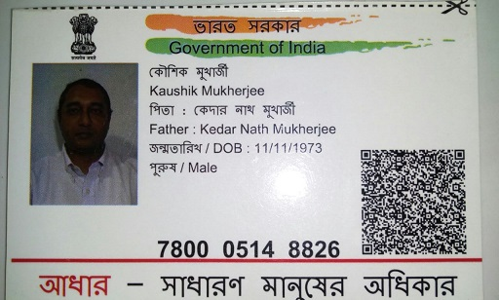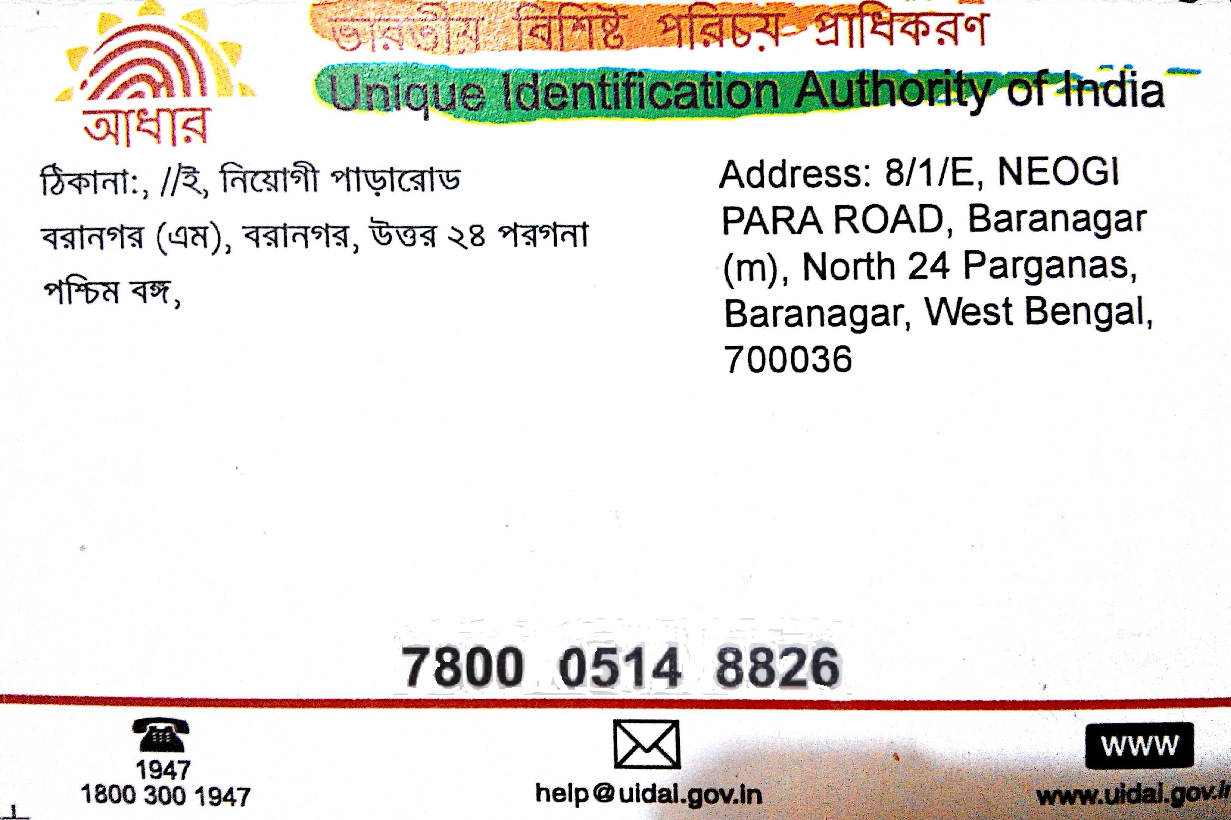

**Santanu Karmakar – Aadhar Card**

